Top 10 tips for Writing a Resume with Limited Work Experience
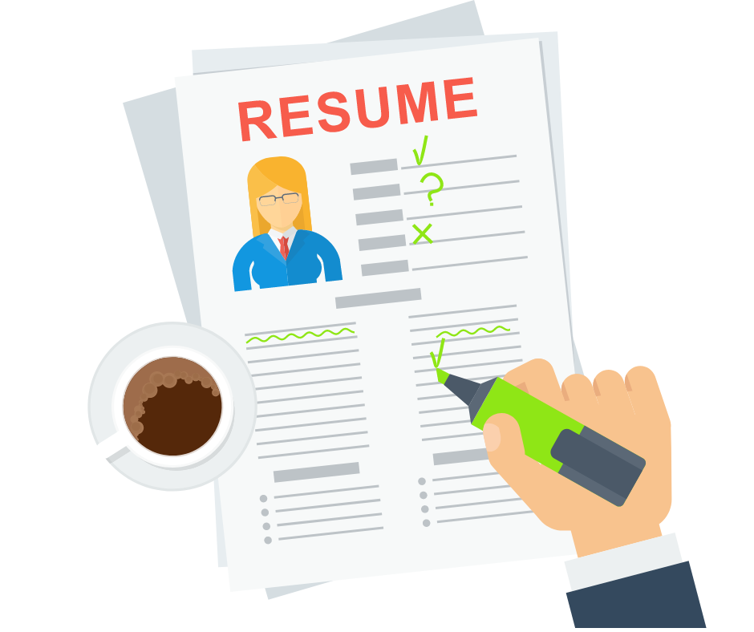

Work Experience helps you stand apart from the rest while applying for jobs. The more work experience you have, the better it is for you to develop your career. Gaining significant work experience is beneficial to showcase your efforts & responsibilities.
But what if you are a fresher who has just now embarked on a journey towards the professional world? You may have limited or no work experience which may hinder your chances of getting ahead in your career.
This blog will discuss the proper resume format for freshers with limited or no work experience. It will discuss 10 important points that you can add to your resume that will make you look like a professional.

Mention your Contact Information
Your full name, phone number, email address & LinkedIn profile are all the necessary information required to be added to your resume. Providing your contact information ensures that employers can easily reach out to you for further communication, such as scheduling interviews or follow-up discussions along with demonstrating your professionalism.

Focus on Skills & Accomplishments
Have you volunteered, interned or gained some awards for your accomplishments? These things can be on your resume. Mention your volunteer experience, internship experience in detail & highlight the skills that you achieved while on the job. Do not forget to mention your accomplishments in detail too.

Use a Functional or Combination format
A Functional resume format is particularly useful when you have limited work experience, are changing careers, or have gaps in your employment history. Unlike a traditional chronological resume that focuses on your work history, a functional resume emphasizes your skills & abilities.
On the other hand, a Combination resume also known as a hybrid resume, blends elements of both the chronological & functional resume formats. It focuses on highlighting your skills & accomplishments while also providing a chronological work history.

Include a strong Summary or Objective Statement
Briefly summarize your key skills & attributes. A strong summary can help you showcase your talent along with making you stand out from the crowd. State what kind of position you are seeking & what skills you bring to the table.

Highlight Education & Academic qualifications
List your educational background in reverse chronological order (most recent first). Also include the name of your school or institution, degree obtained or in progress, & graduation date (or expected graduation date). If you have a high GPA or relevant coursework, do not forget to mention it.

Include Relevant Experience
In this section, you can include any work experience like internships, part-time jobs, volunteer work, or freelance gigs. For each position, mention the job title, company or organization, location & dates of employment. Describe your responsibilities & achievements using action verbs (e.g., organized, led, developed).
For a detailed understanding on using action words in your resume, read this blog here.

Emphasize Transferable Skills
Transferable Skills are those skills that you learn at a certain job & then carry it along to your next. They can include communication skills, teamwork & collaboration, problem solving abilities, etc. Organize your resume by skills rather than job titles. Create sections such as "Skills," "Key Abilities," or "Core Competencies" where you list relevant transferable skills.

Quantify Achievements wherever possible
Quantifying achievements provides concrete evidence of how your efforts contributed to specific results, such as increasing sales by a certain percentage, reducing costs, or improving efficiency. It distinguishes your achievements from simple job duties, adding credibility.

Include Relevant Keywords
Even with limited work experience, using keywords demonstrates that you have a solid understanding of the industry & the specific skills required for the job. It shows that you are proactive in aligning your qualifications with the employer's needs. By strategically using keywords in your resume, you can enhance your chances of getting noticed & demonstrate your qualifications effectively.

Highlight Extracurricular activities & Personal Projects
Highlighting extracurricular activities & personal projects on your resume is crucial because they can demonstrate a range of valuable skills & qualities that are relevant to the job you are applying for, especially if you have limited formal work experience. They indicate your commitment & dedication outside of academic studies along with showing your proactiveness & willingness.

Conclusion
As you have limited work experience, aim for a one-page resume. Tailor your resume for each job application by emphasizing skills & experiences relevant to the specific role. Visit the PaintMinds website right away to get your resume crafted by experts & career coaches who have worked on 100+ resumes & professional profiles

Keywords: Work experience | Resume format for freshers | Volunteer experience | Internship Experience | Functional resume | Combination resume
Title tag: Resume Format tips for Freshers
Meta tag: Limited Work Experience – Build your resume the right way | PaintMinds
Meta Description: Are you a fresher who has just now embarked on a journey towards the professional world? You may have limited or no work experience which may hinder your chances of getting ahead in your career. Read this blog to know about the top 10 tips without worrying about your limited work experience.

